**Study on Command line text editor**

1.nano (for checking the version )

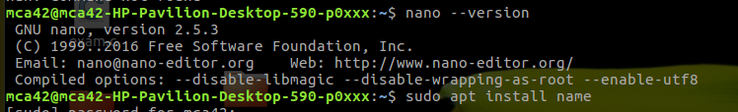

2.sudo apt install name(for installing purpuse)

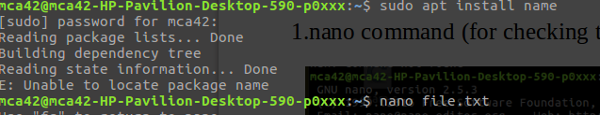

3.nano file.txt

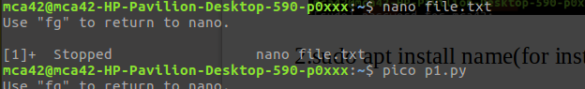

4.pico p1.py

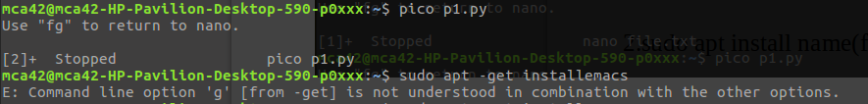

5. to install a application

a.sudo apt update

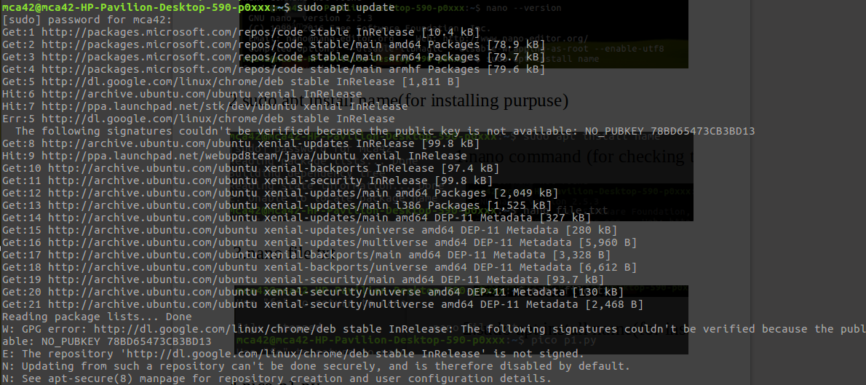

b.sudo apt install eclipse

